**Course Project Report Format- Applied Electronics**

**Battery Level Indicator**

1. Shaunak Deshpande; GR No: 11911180; Div: SY-ICC; Roll No:04
2. Gaurav Shejwal; GR No: 11910808; Div: SY-ICC; Roll No:05
3. Shrawani Shinde; GR No: 11911031; Div: SY-ICC; Roll No:09
4. Shivang Singh; GR No: 11910405; Div: SY-ICC; Roll No:12

**Introduction**

Knowing the amount of energy left in a battery compared with the energy it had when it was full gives the user an indication of how much longer a battery will continue to perform before it needs recharging. This problem could be solved by batter level indicator. Battery level indicator indicates the status of the battery just by glowing LED’s. For example, six LEDs are glowing means battery capacity 60% remains. By using this circuit, we can increase the lifetime of battery also we can use this circuit to check car battery or inverter.

**Feasibility Study**

Sometimes there is nothing worse than losing all the charges on your device unknowingly and as a result of this your device shuts down especially when you are in the middle of something very important. Usually this happens at the most inconvenient time probably when you are using your device for something very important. Battery level indicator was invented to solve this problem. Battery level indicator is the project that indicates status of battery by use of LED. This project can know the status of battery left. This is can give easier to people and can be more alert then about status of battery level. Battery level indicator can present a circuit that can know the battery level of a device from the number of LED glowing.

Many devices have a battery-level indicator which lets us know how much battery power has left. Having a battery-level indicator on devices is like having a fuel gauge on your car. Knowing when the battery is about to run out means you can prepare for it, rather than being caught off-guard when the tool/ device stops in the middle of a task.

For example, Battery level indicator is used in some cordless screwdrivers. The indicator gives you a good idea of how much battery power is being used when working with certain materials or bits. For example, working with tougher materials and larger screws will use more battery power.

**Methodology/ Planning of work**

Low voltage or Over-charging in batteries can make the plates swell and can cause internal shorts. It shortens the life in batteries, even if you don't get shorts. It also causes the plates to deteriorate faster than just regular charging. A float charge to balance is not the bad overcharging that causes a lot of water to boil out. The main objective of this work is to construct a device that will indicate and let the user know the status of battery of a device just number of LED's.

To achieve the aim and objectives of this work, the following are the steps involved:

* Study of the previous work on the project so as to improve it efficiency.
* Draw a block diagram.
* Test for continuity of components and devices.
* Design and calculation for the device was carried out.
* Studying of various component used in circuit.
* Construction of the circuit was carried out.
* Finally, the whole device was cased and final test was carried out.

**Project Description and Working**

The heart of this battery level indicator circuit is LM3914 IC. In this circuit there

is no need of resistors in series with LEDs because current is regulated by the IC.

Features of LM3914 Drives LEDs, LCDs or Vacuum Fluorescents.

* Bar or Dot Display Mode Externally Selectable by User.
* Expandable to Displays of 100 Steps.
* Internal Voltage Reference from 1.2V to 12V.
* Operates with Single Supply of Less than 3V.
* It supports wide range of temperature from 0 to 70 degree Celsius.
* For bar graph display – connect 9th pin of IC to the supply.
* For dot display – leave the 9th pin of IC.

In this circuit LED’s (D1-D10) displays the capacity of the battery in either dot

mode or display mode. This mode is selected by the external switch sw1 which is

connected to 9th pin of IC. 6th and 7th pins of IC are connected to the ground

through a resistor. This resistor controls the brightness of LED’s. Here resistor R3

and POT RV1 forms potential divider circuit. Here pot RV1 is used for calibration.

There is no need of any external power supply to this circuit. Connect D1 to D10

red LED’s which indicates shut down stage of our battery.

While operating:

1. Connect 12V DC battery to the input.
2. Now adjust the pot RV1 so that LED D1 just starts glowing.
3. Now increase the input Dc voltage slowly and observe the LED’s
4. First led will glow for 1.2V and second LED is for 2.4 V and so on.

**Observations**

Below is the observation table:

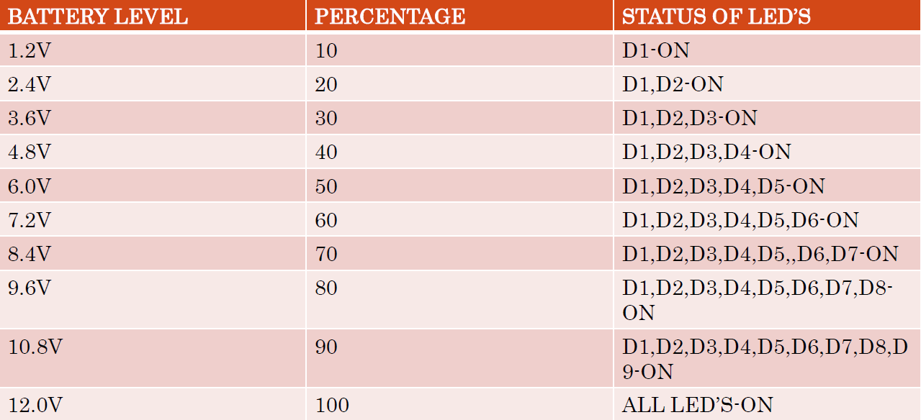

**Conclusion**

Battery level indicator will let you know the status of battery of a device just by glowing the number of LED's

**Annexure:**

**A: Screenshots and Photographs of the project**

Circuit:

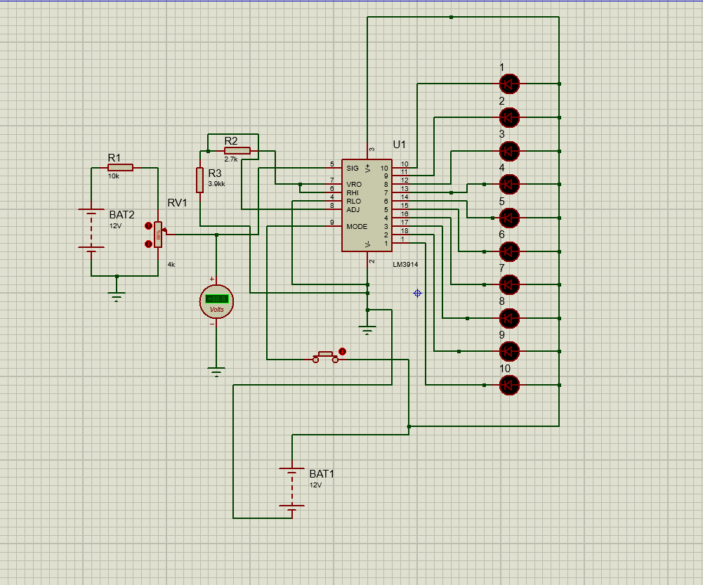

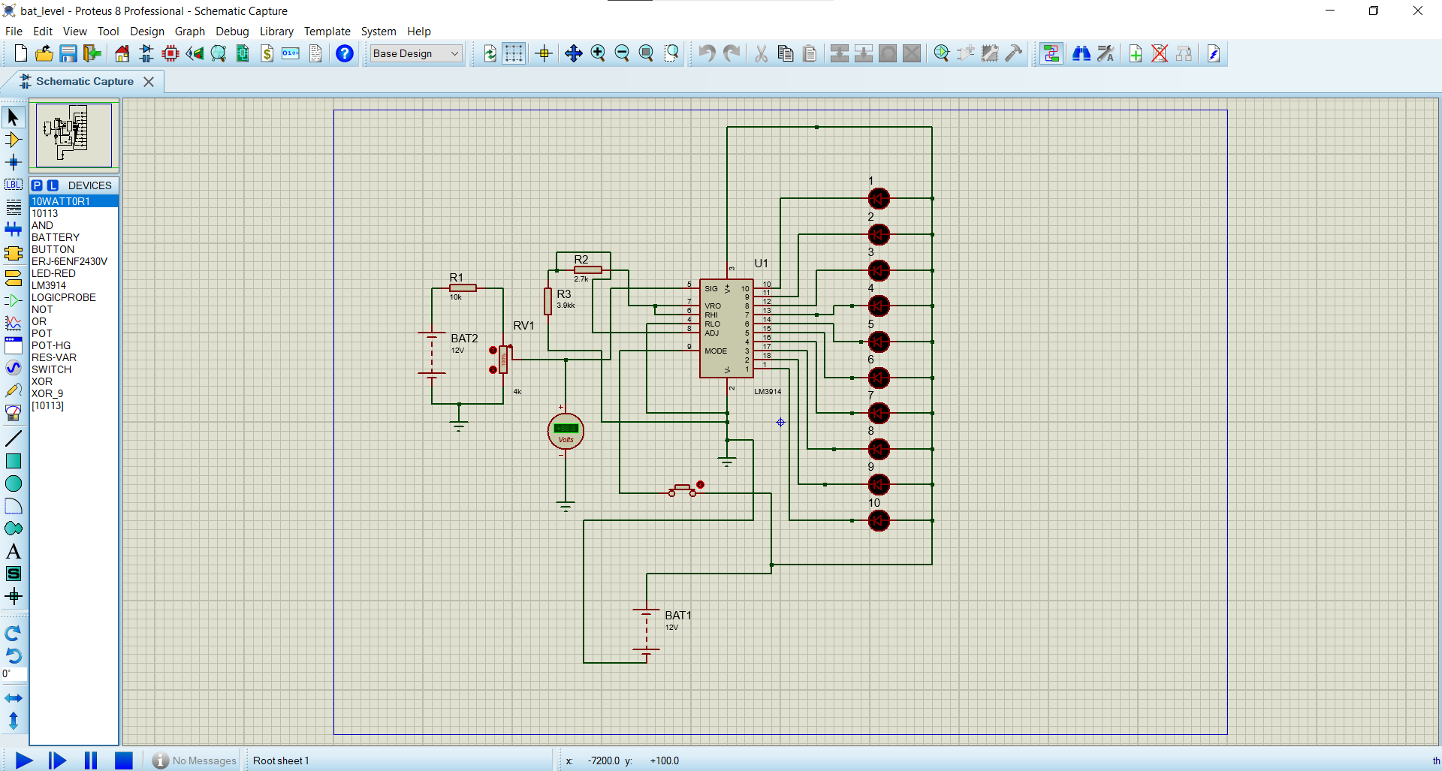

When voltage is 100 percent, that is 12V.

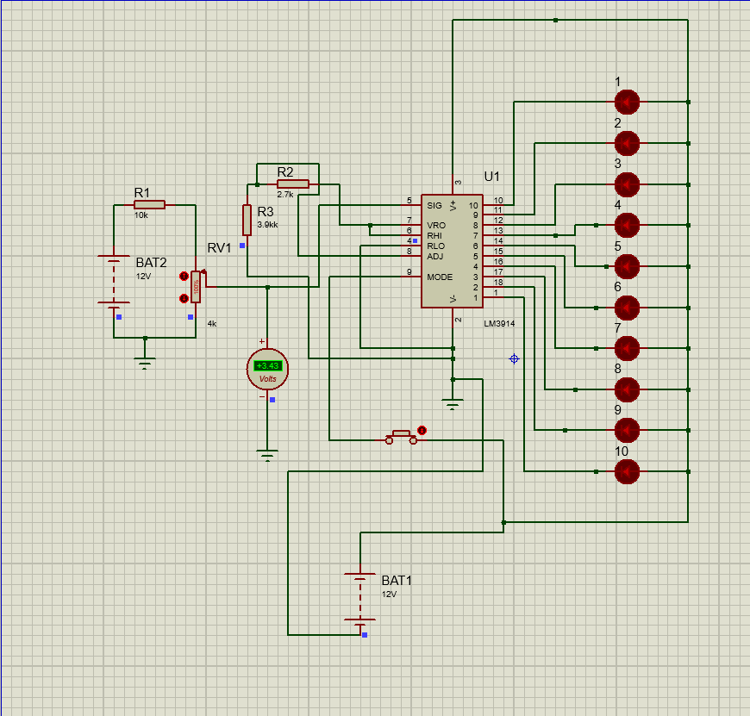

Changes in voltage:

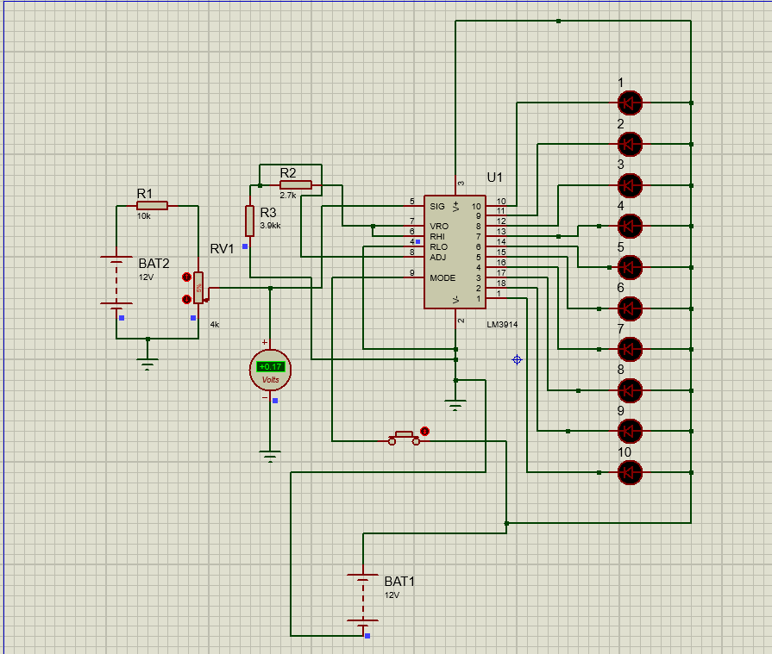 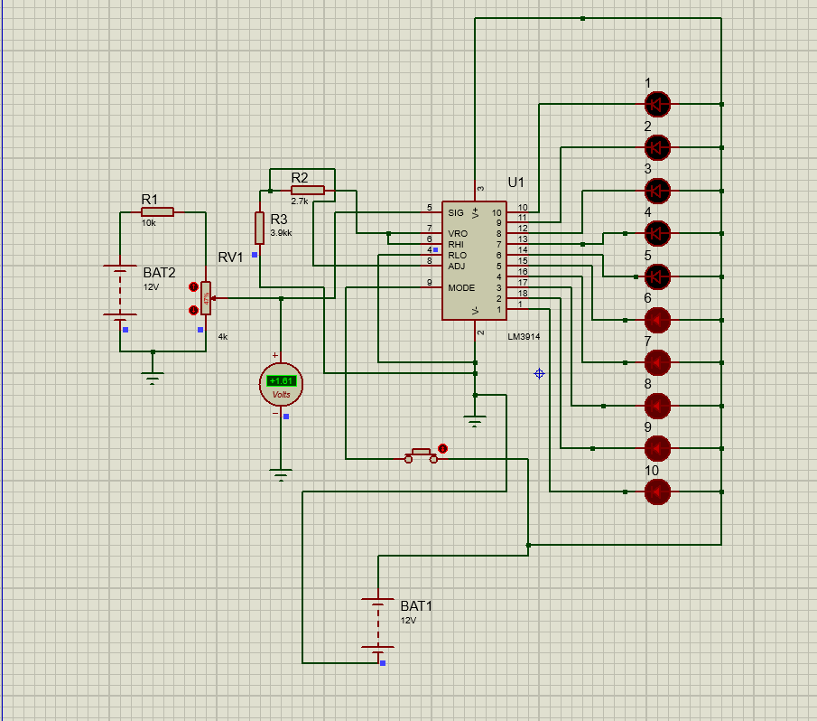

**References**.

[**https://www.electronicshub.org/battery-level-indicator/**](https://www.electronicshub.org/battery-level-indicator/)

[**https://www.wonkeedonkeetools.co.uk/cordless-screwdrivers/what-is-the-battery-level-indicator#:~:text=What%20are%20the%20advantages%20of,the%20middle%20of%20a%20task**](https://www.wonkeedonkeetools.co.uk/cordless-screwdrivers/what-is-the-battery-level-indicator#:~:text=What%20are%20the%20advantages%20of,the%20middle%20of%20a%20task)**.**

[**https://en.wikipedia.org/wiki/Battery_indicator**](https://en.wikipedia.org/wiki/Battery_indicator)

[**http://dspace.unimap.edu.my/xmlui/handle/123456789/44292**](http://dspace.unimap.edu.my/xmlui/handle/123456789/44292)